Test Case: tc006_SPX_Dev5_Crear_Requisicion_Spot_Tipo_Cobro_Proyect_Urgent
Step 1 - Enter username and password and click to button Enter: Credentials Entered
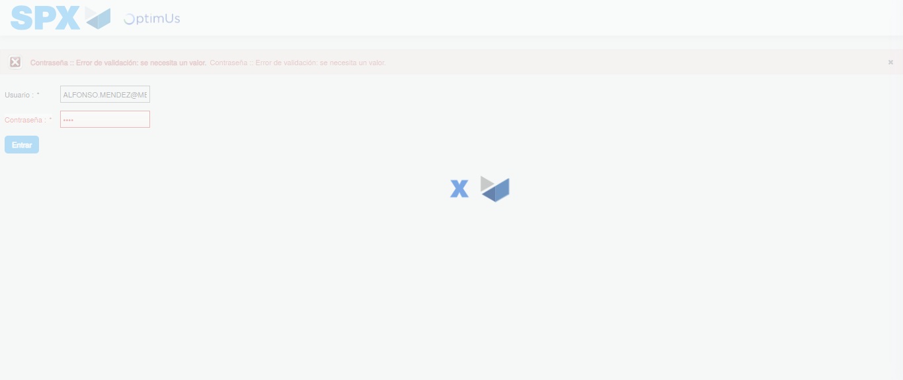Image file-name: QC_Testing-tc006_SPX_Dev5_Crear_Requisicion_Spot_Tipo_Cobro_Proyect_Urgent-1783379333374

Step 2 - Select to UEN and Access to Spot Buy Requisitions : UEN Correctly selected and Correct access
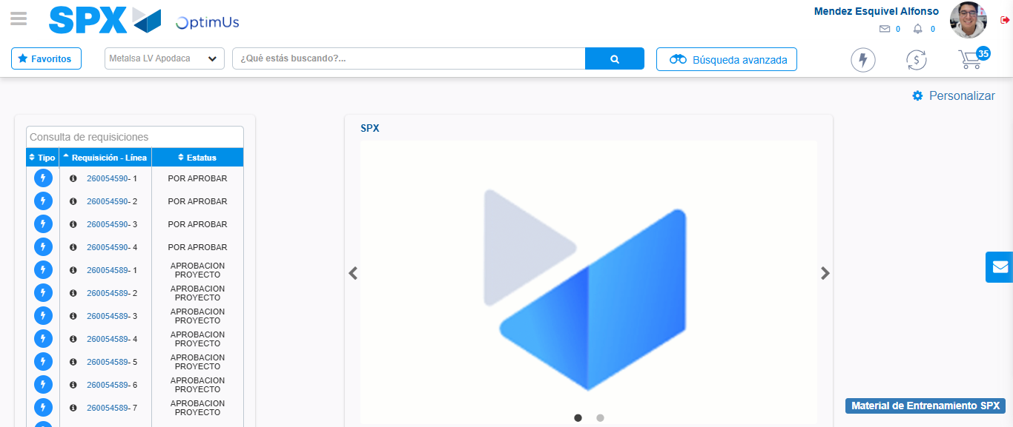Image file-name: QC_Testing-tc006_SPX_Dev5_Crear_Requisicion_Spot_Tipo_Cobro_Proyect_Urgent-1783379359551

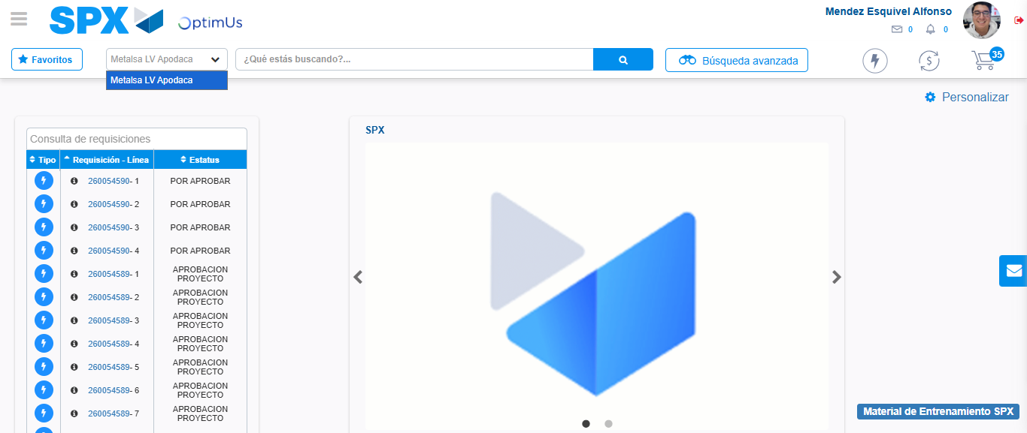Image file-name: QC_Testing-tc006_SPX_Dev5_Crear_Requisicion_Spot_Tipo_Cobro_Proyect_Urgent-1783379362052

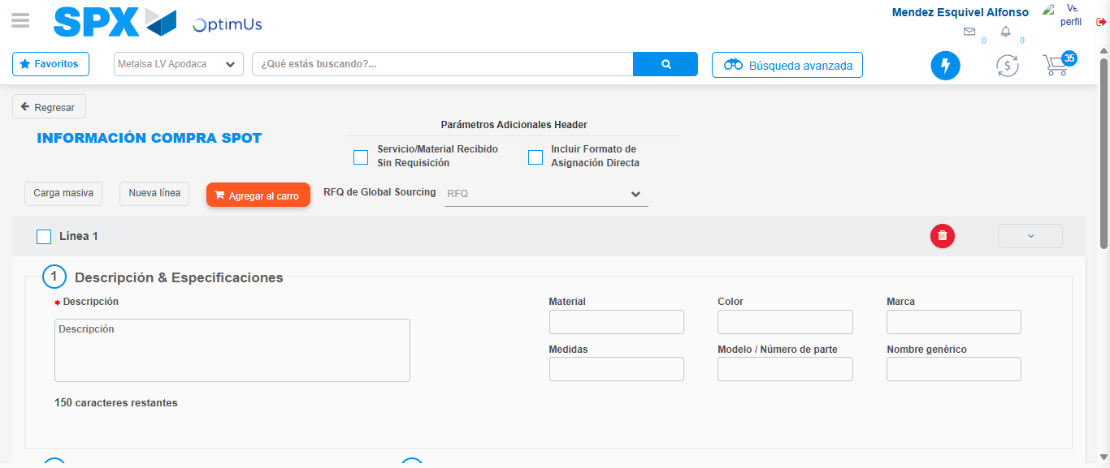Image file-name: QC_Testing-tc006_SPX_Dev5_Crear_Requisicion_Spot_Tipo_Cobro_Proyect_Urgent-1783379384322

Step 3 - Data Capture Spot Buy Requisition: Data captured correctly
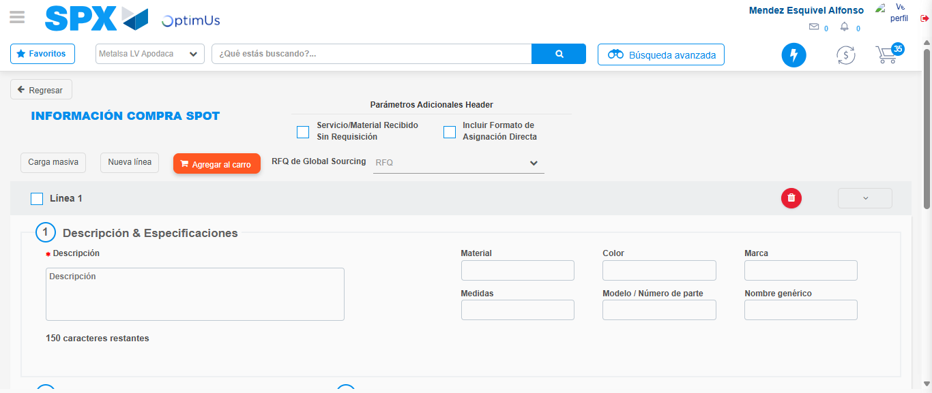Image file-name: QC_Testing-tc006_SPX_Dev5_Crear_Requisicion_Spot_Tipo_Cobro_Proyect_Urgent-1783379384638

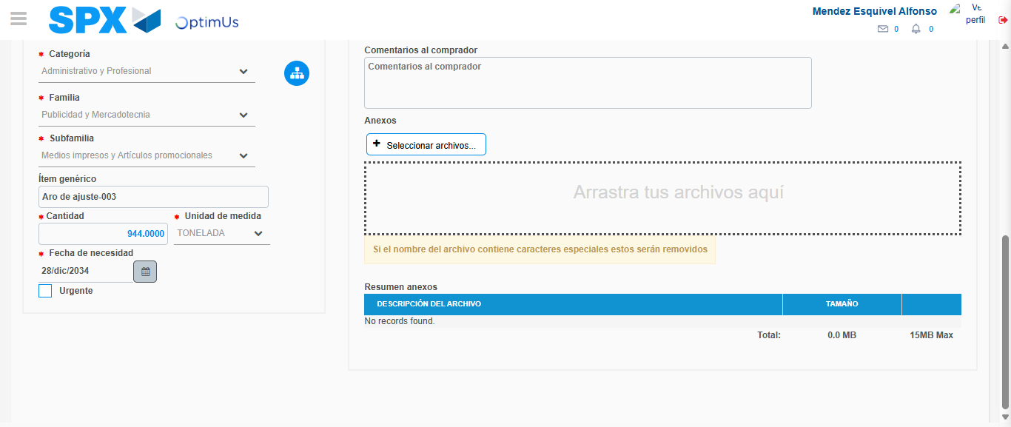Image file-name: QC_Testing-tc006_SPX_Dev5_Crear_Requisicion_Spot_Tipo_Cobro_Proyect_Urgent-1783379395163

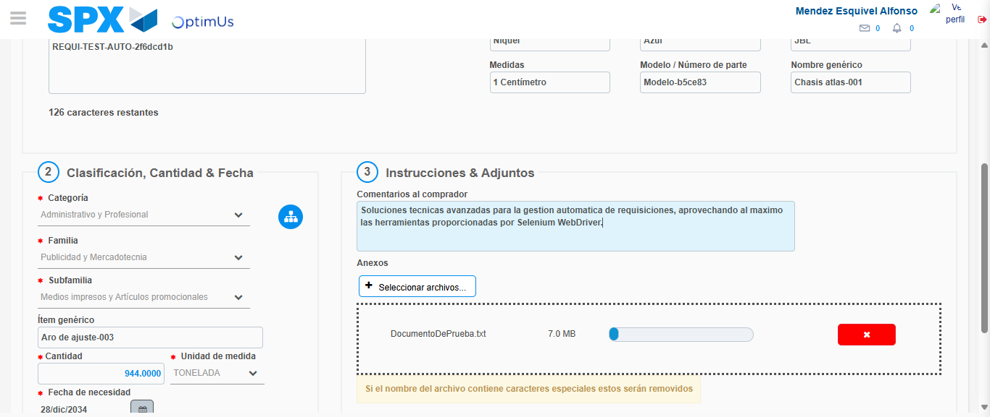Image file-name: QC_Testing-tc006_SPX_Dev5_Crear_Requisicion_Spot_Tipo_Cobro_Proyect_Urgent-1783379395896

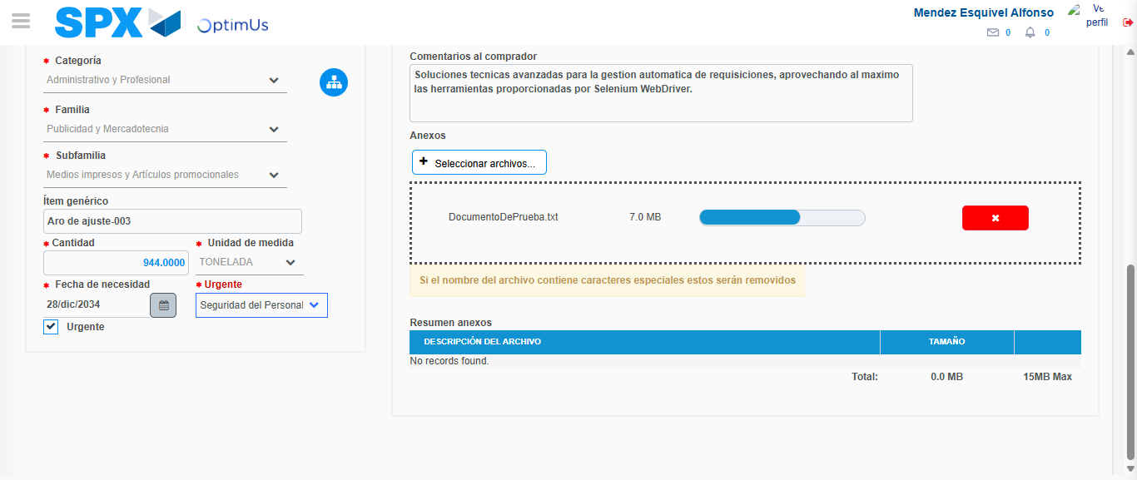Image file-name: QC_Testing-tc006_SPX_Dev5_Crear_Requisicion_Spot_Tipo_Cobro_Proyect_Urgent-1783379399491

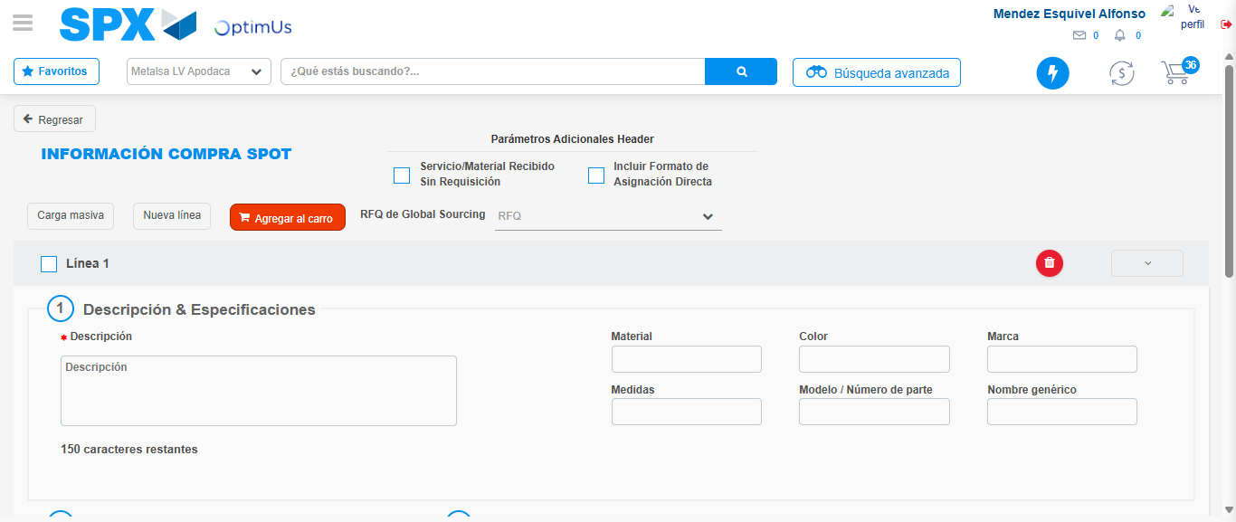Image file-name: QC_Testing-tc006_SPX_Dev5_Crear_Requisicion_Spot_Tipo_Cobro_Proyect_Urgent-1783379407361

Step 7 - Return to Main Page SPX : Return to Main Page SPX
Image file-name: QC_Testing-tc006_SPX_Dev5_Crear_Requisicion_Spot_Tipo_Cobro_Proyect_Urgent-1783379359551

Image file-name: QC_Testing-tc006_SPX_Dev5_Crear_Requisicion_Spot_Tipo_Cobro_Proyect_Urgent-1783379362052

Image file-name: QC_Testing-tc006_SPX_Dev5_Crear_Requisicion_Spot_Tipo_Cobro_Proyect_Urgent-1783379384322

Image file-name: QC_Testing-tc006_SPX_Dev5_Crear_Requisicion_Spot_Tipo_Cobro_Proyect_Urgent-1783379409604

Image file-name: QC_Testing-tc006_SPX_Dev5_Crear_Requisicion_Spot_Tipo_Cobro_Proyect_Urgent-1783379409777

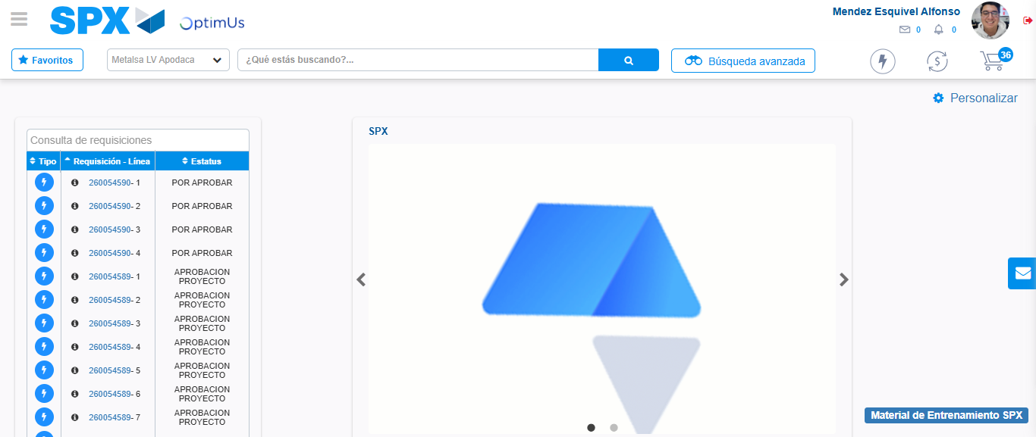Image file-name: QC_Testing-tc006_SPX_Dev5_Crear_Requisicion_Spot_Tipo_Cobro_Proyect_Urgent-1783379430893

Step 8 - Log Out : Log Out SPX
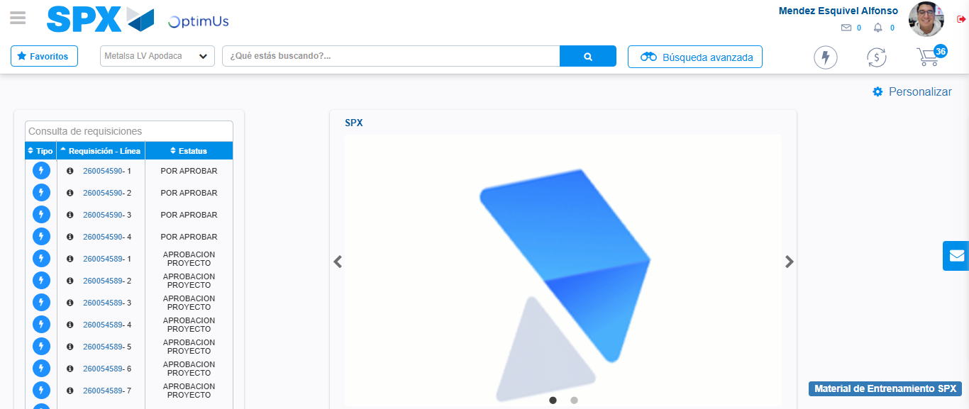Image file-name: QC_Testing-tc006_SPX_Dev5_Crear_Requisicion_Spot_Tipo_Cobro_Proyect_Urgent-1783379431127

